|  |
| --- |
| CS 113 / INF 125 |
| Working Title |
| Version 1.2  All work Copyright © 2011 by the University of California, Irvine.  All rights reserved. |
| **Joshua Fulmer** |
|  |

|  |
| --- |
| November 22, 2011 |

**Table of Contents**

1. **Game Overview.................................................................................. 4**
2. **Game Play Mechanics………………………………………………………………………. 4**
3. **Camera…………………………………………………………………………………………….. 4**
4. **Controls……………………………………………………………………………………………. 4**
5. **Interface…………………………………………………………………………………………… 5**
6. **Menu and Screen Descriptions…………………………………………………………. 6**
7. **Game World……………………………………………………………………………………. 6**
8. **Game Modes……………………………………………………………………………………. 6**
   1. **Free-For-All………………………………………………………………… 6**
   2. **Team Based………………………………………………………………… 7**
   3. **Collection Mode…………………………………………………………. 7**
9. **Progression………………………………………………………………………………………. 7**
10. **Enemies……………………………………………………………………………………………. 7**
11. **Weapons………………………………………………………………………………………….. 7**
12. **Scoring…………………………………………………………………………………………….. 8**
13. **Art Bible…………………………………………………………………………………………… 8**

**Version History**

October 1st, 2011 Joshua Fulmer Version 1.0

October 17th, 2011 Joshua Fulmer Version 1.1

November 22, 2011 Joshua Fulmer Version 1.2

1. **Game Overview**

[Working Title] is a fast paced action - puzzle game in which the player(s) must guide a horde of garden gnomes as they race around the board. Players must attempt to guide the friendly red gnomes to their respective bases in order to receive points, while ensuring that the evil purple gnomes stay out of the player’s home base. The player with the most points at the end of the game wins!

1. **Game Play Mechanics**

The object of the game is to guide the garden gnomes around the board by strategically placing arrows or 'directional indicators' on the board in order to manipulate the movement of the game pieces. All of the game’s 'entities' move in a predictable pattern by always turning right upon hitting a wall head on, by following corners or by redirecting themselves when a dead end is reached.

Each player may only have four direction markers on the screen at any given point. They can either be manually removed by the player, or automatically by placing a fourth arrow. In addition, there are also special entities (random event gnomes) that arrive on the screen that will cause a variety of special in game events.

1. **Camera**

The game includes a static overhead 2D camera.

1. **Controls**

[Working Title], built in Microsoft XNA, will use the standard Xbox 360 wired controller for each player:

Left ThumbStick: Player Cursor Movement

A Button: Add Downward Arrow

B Button: Add Right Arrow

X Button: Add Left Arrow

Y Button: Add Upward Arrow

Right Trigger: Remove Arrow from selected tile

Left Trigger: Remove all arrows

1. **Interface**

Please see the proposed mock up below:

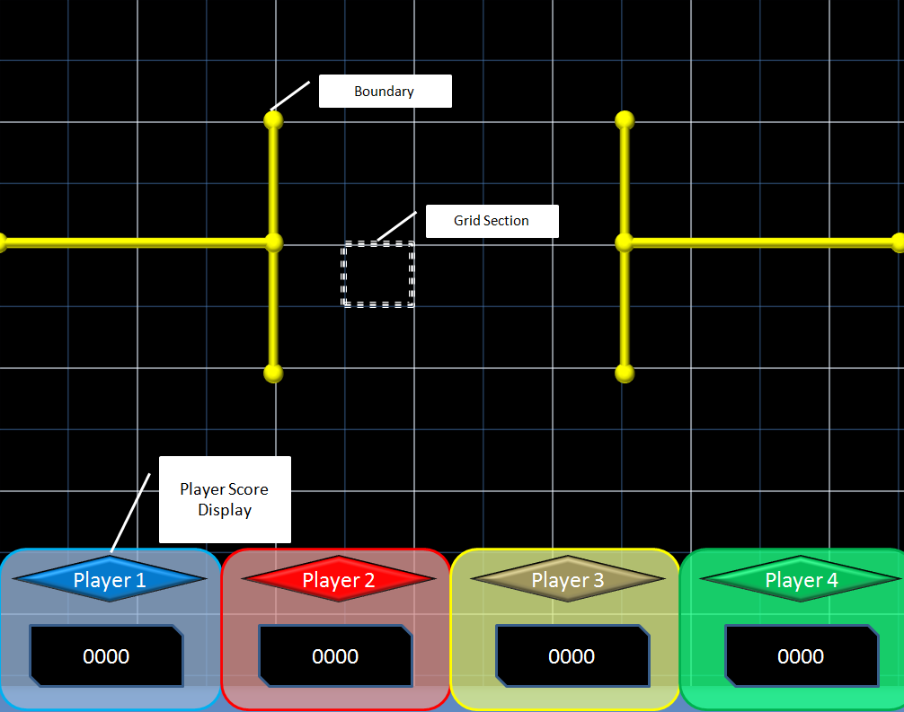

The game will consist of a grid field in which the players will place the directional markers, either up, down, left, or right. The game environment may include boundaries that of which no game entity can cross.

Also included in the User Interface is the current player score compared to all other players. Each player will be assigned a specific color to simplify identification.

1. **Menu and Screen Descriptions**

Menu and Pause screen will consist of the following options:

**Menu:**

* Play: Enter the game
* Instructions: View the game instructions
* Credits: View the game credits
* Exit: Exit the program

**Pause:**

* Resume: Resume the current game
* Instructions: View the game instructions
* Main Menu: Return to the main menu
* Exit: Exit the program

1. **Game World**

The game world can be described as the visualization of a suburban backyard filled with grass and hedges, in which carefree garden gnomes run wildly about. The player’s are abstract entities that direct the gnomes about the garden.

1. **Game Modes**
   1. **Free For All**

The default game play is a 4 - player free for all game where each player has a 'base'. Each player attempts to redirect as many sprites as possible into their base while ensuring that other players do not obtain any. At the end of the game, the player with the most points wins.

This game can either end based on a timer (5 minute game time.) or after a specified number of sprites have been spawned. (100 sprites total.)

* 1. **Team Based Mode**

Similar to the Free-for-All mode, except that the player’s are divided into two teams. Each player has a separate base, however two bases of each individual on a team or combined and added at the end of the game to create a total score.

* 1. **Collection mode**

In this mode, there are only 4 gnomes, each belonging to a specific player. The goal of this mode is to have your gnome collect items on the field and return them back to your home base.

1. **Game Progression**

In a future build, progression will be speed based. Meaning that as the game moves forward, it will become progressively faster. For example, the start of free-for-all mode may have a few gnomes on the screen at once, but as the game progresses additional gnomes will spawn at a faster rate.

1. **Enemies**

In addition to normal “red gnomes”, purple colored gnomes will also spawn throughout the normal gameplay. Each player should avoid collected these gnomes as they will deduct points from your overall score!

1. **Weapons**

There are no conventional weapons in [Working Title]. The only weapons can be defined as follows:

* The player arrows, used to direct gnomes both in and out of bases.
* The evil gnomes, which can be directed to negatively affect an opponent.

1. **Scoring**

Scoring is currently based on the following values:

Red Gnome: 10 points

Evil Gnome: -50 points

Random Gnome: 100 points + random in game event

1. **Puzzles/Mini-games**

**\*TBD\***

1. **Sound Bible**

**\*TBD\***

1. **Art Bible**

The standard size of each game tile is 64 by 64 pixels. Each art asset is created and adjusted with this in mind.

Below you can find all art assets as well as descriptions for each:



**Player Arrows:** Used by each player to direct sprites on the game board. Each player may only place at most four at any given time.



**Background Art**: The background image that is persistently present throughout the game play. It is possible that multiple variations of this art may be produced to ensure map variability.

**C:\Documents and Settings\testrecp\Desktop\Josh\inf125-team-k\Tile Engine\Tile Engine\Tile EngineContent\button-dim-left.png**C:\Documents and Settings\testrecp\Desktop\Josh\inf125-team-k\Tile Engine\Tile Engine\Tile EngineContent\button-dim-middle.pngC:\Documents and Settings\testrecp\Desktop\Josh\inf125-team-k\Tile Engine\Tile Engine\Tile EngineContent\button-dim-right.pngC:\Documents and Settings\testrecp\Desktop\Josh\inf125-team-k\Tile Engine\Tile Engine\Tile EngineContent\button-lit-left.pngC:\Documents and Settings\testrecp\Desktop\Josh\inf125-team-k\Tile Engine\Tile Engine\Tile EngineContent\button-lit-middle.pngC:\Documents and Settings\testrecp\Desktop\Josh\inf125-team-k\Tile Engine\Tile Engine\Tile EngineContent\button-lit-right.png

**Button Art:** Original created by David Frankel, it is used to display button transitions in the menu systems.



**Cursor:** Used by each player to navigate the game board. In game the cursor will be represented by different colors respective to each player.

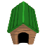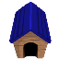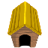

**Player Base:**  Represents the player base location on the game map.



**Regular “Red” Gnomes**

****

 **Purple “Evil” Gnomes**

**Yellow “Random” Gnomes**

**Gnomes:** The in game entities that are manipulated by the player’s directional arrows.

C:\Documents and Settings\testrecp\Desktop\Josh\inf125-team-k\Tile Engine\Tile Engine\Tile EngineContent\wall_verticle.png

C:\Documents and Settings\testrecp\Desktop\Josh\inf125-team-k\Tile Engine\Tile Engine\Tile EngineContent\wall_horizontal.png

**Hedges:** Game entities used to represent boundaries that gnomes cannot cross.